**DAILY ONLINE ACTIVITIES SUMMARY**

|  |  |  |  |  |  |  |  |  |
| --- | --- | --- | --- | --- | --- | --- | --- | --- |
| **Date:** | **02/06/2020** | | | | | **Name:** | **Katira Krishna J** | |
| **Sem & Sec** | **8th A** | | | | | **USN:** | **4AL16CS045** | |
| **Online Test Summary** | | | | | | | | |
| **Subject** | | **-** | | | | | | |
| **Max. Marks** | | **-** | | **Score** | | | **-** | |
| **Certification Course Summary** | | | | | | | | |
| **Course** | **Build Swift Mobile Apps with Watson AI Services** | | | | | | | |
| **Certificate Provider** | | | **Cognitiveclass.ai** | | **Duration** | | | **2.5 Hours** |
| **Coding Challenges** | | | | | | | | |
| **Problem Statement: Python program to check amicable numbers** | | | | | | | | |
| **Status: Completed** | | | | | | | | |
| **Uploaded the report in Github** | | | | | **yes** | | | |
| **If yes Repository name** | | | | | **Krishna_Katira** | | | |
| **Uploaded the report in slack** | | | | | **yes** | | | |

Online Test Details:

Not Conducted

Certification Course Details:

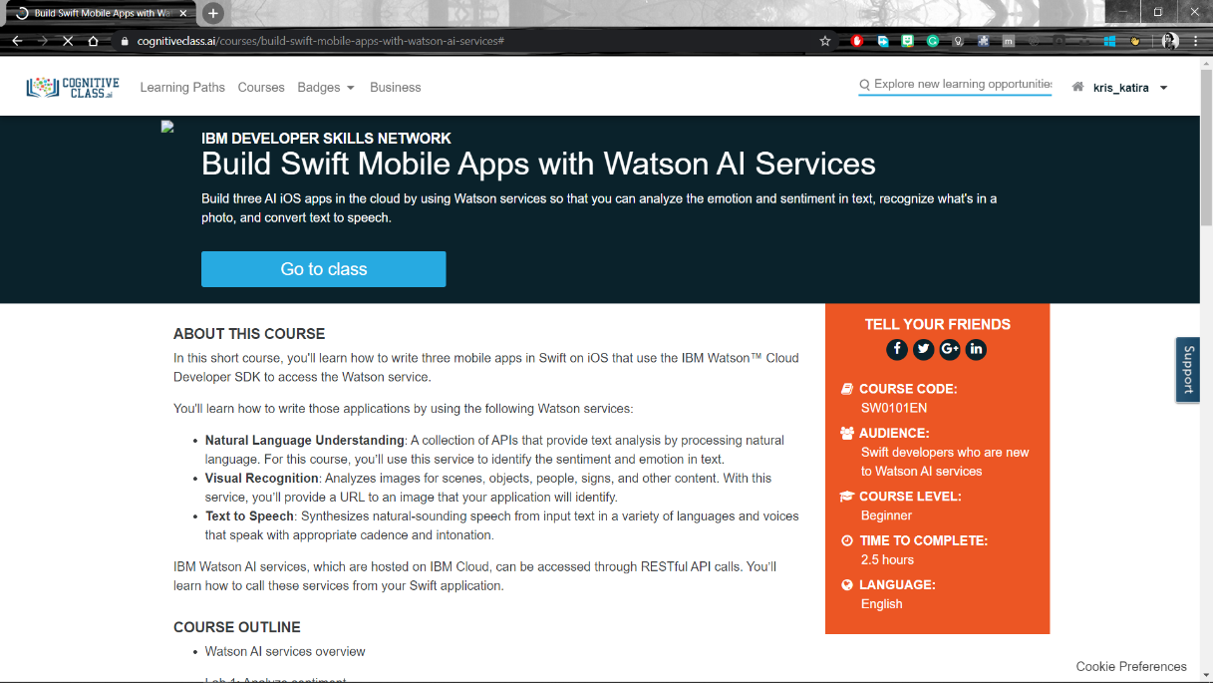

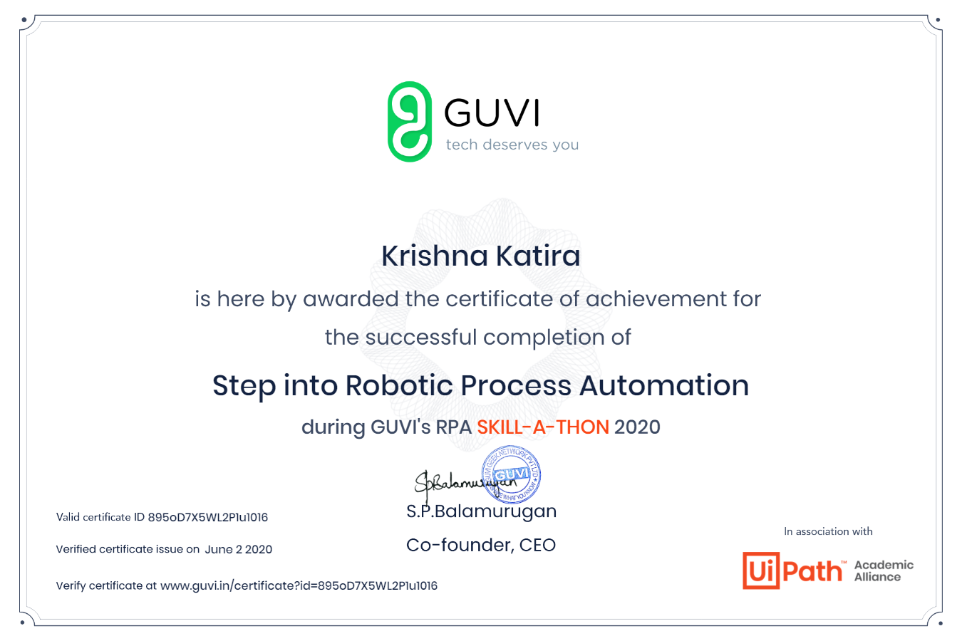

Coding Challenges Details:

**program1**

x=int(input('Enter number 1: '))

y=int(input('Enter number 2: '))

sum1=0

sum2=0

**for** i **in** range(1,x):

**if** x%i==0:

sum1+=i

**for** j **in** range(1,y):

**if** y%j==0:

sum2+=j

**if**(sum1==y **and** sum2==x):

**print**('Amicable!')

**else**:

**print**('Not Amicable!')